Date:23/01/2026
9.Create a Snapshot of a VM and Test it by loading the Previous Version/Cloned VM using a virtual box.

AIM: To create a snapshot of a virtual machine (VM) in Oracle VirtualBox and test the snapshot by reverting to a previous version / cloned VM.
SOFTWARE USED
- Oracle VM VirtualBox – for creating, managing, snapshotting, and restoring virtual machines
- Guest Operating System (e.g., Windows / Ubuntu / Linux) – installed inside the virtual machine
PROCEDURE:

- Open Oracle VM VirtualBox on the host system.
- Select the required virtual machine from the VirtualBox Manager.
- Start the virtual machine and ensure it boots properly.
- Shut down the virtual machine safely.
- Click on Snapshots in the VirtualBox Manager.
- Select Take Snapshot and provide a name and description.
- Save the snapshot of the virtual machine.
- Restart the virtual machine and make changes such as installing software or modifying files.
- Power off the virtual machine after making changes.
- Select the previously created snapshot from the snapshot list.
- Click Restore Snapshot to load the previous version of the virtual machine.
- Start the virtual machine and verify that the system has reverted to its earlier state.

Output:
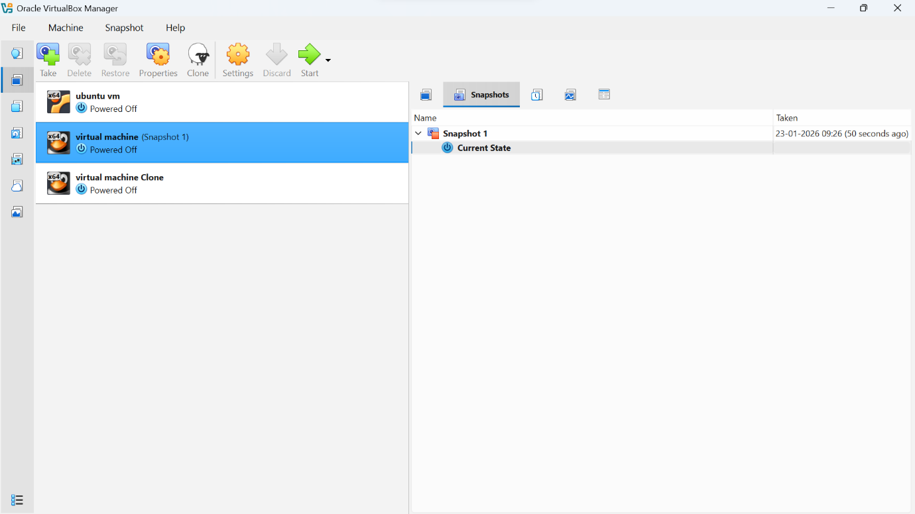

RESULT: The snapshot of the virtual machine was successfully created using Oracle VM VirtualBox. After restoring the snapshot, the virtual machine reverted to its previous state, and all changes made after the snapshot were removed. This confirms that the snapshot and restore functionality works correctly in VirtualBox.

